Immediate Vacancies & Replenish Waiting List

**[PROJECT NAME]**

**[ADDRESS], [NEIGHBORHOOD], [BOROUGH], [ZIP CODE]**

*New York City is committed to the principle of inclusivity in all of its neighborhoods, including supporting New Yorkers to reside in neighborhoods of their choice, regardless of their neighborhood of origin and regardless of the neighborhood into which they want to move.*

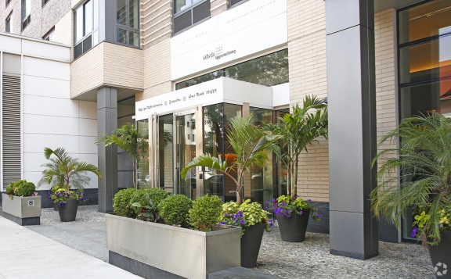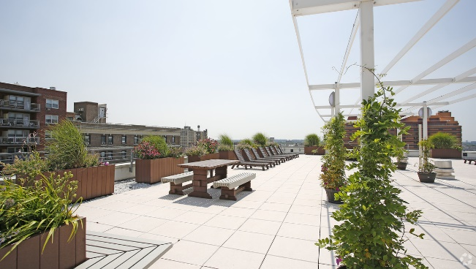

[INSERT BUILDING IMAGES HERE]

**Amenities:** [INSERT AMENITIES HERE]

**Transit:** [LIST TRAINS] [LIST BUSES]

**No application fee • No broker’s fee • Pet [FRIENDLY OR FREE] building**

Applications are now being accepted to replenish the waiting list. Individuals or households who meet the income and household size requirements listed in the table below may apply. Qualified applicants will be required to meet additional selection criteria such as asset limits.

**UNIT(S) FOR WAITING LIST**

|  |  |  |  |  |
| --- | --- | --- | --- | --- |
| **Unit Size(s)** | **Monthly Rent Range1** | **House-hold Size(s)2** | **Annual Household Income3** Minimum – Maximum**4** | **Disability Designation** |
| **40% AREA MEDIAN INCOME (AMI)** | | | | |
| Studio - 1 Bedroom | $XXX - $XXX | 1 - 2 People | $16,938 - $29,670 | Mobility |
| **50% AREA MEDIAN INCOME (AMI)** | | | | |
| 1 – 2 Bedroom | $XXX - $XXX | 1 - 5 People | $16,938 - $29,670 | Vision and Hearing |
| **60% AREA MEDIAN INCOME (AMI)** | | | | |
| 2 - 3 Bedroom | $XXX - $XXX | 2 - 7 People | $16,938 - $29,670 | N/A |

**UNIT(S) AVAILABLE FOR IMMEDIATE LEASING**

|  |  |  |  |  |  |  |  |  |
| --- | --- | --- | --- | --- | --- | --- | --- | --- |
| **Unit Size** | **40% AREA MEDIAN INCOME (AMI)** | **Monthly Rent1** | **House-hold Size2** | **Annual Household Income3** Minimum – Maximum**4** | **50% AREA MEDIAN INCOME (AMI)** | **Monthly Rent1** | **Household Size2** | **Annual Household Income3** Minimum – Maximum**4** |
| Studio | $XXX | 1 Person | $16,938 - $29,670 | $XXX | 1 Person | $23,075 - $39,560 |
| 2 People | $16,938 - $33,900 | 2 People | $23,075 - $45,200 |
| 1 Bedroom | $XXX | 1 Person | $21,155 - $29,670 | $XXX | 1 Person | $28,835 - $39,560 |
| 2 People | $21,155 - $33,900 | 2 People | $28,835 - $45,200 |
| 3 People | $21,155 - $38,130 | 3 People | $28,835 - $50,840 |

1 Rent includes [INSERT UTILITY HERE]

2 Household size includes everyone who will live with you, including parents and children. Subject to occupancy criteria.

3 Household earnings includes salary, hourly wages, tips, Social Security, child support, and other income­­­. Income guidelines subject to change.

4 Minimum income listed may not apply to applicants with Section 8 or other qualifying rental subsidies. Asset limits also apply.

**How Do You Apply?**

Applications may be requested in person or by mailing a self-addressed envelope to:

**[INSERT AGENT ADDRESS HERE]**

Applications may also be requested by emailing [[INSERT](mailto:info@modaupgradedliving.com) EMAIL HERE] or by calling **[INSERT PHONE HERE]**

**What Happens After You Submit an Application?**

Applications are logged in the order in which they are received. As units become available, applicants on the waiting list who appear to qualify will be contacted to submit documents that verify their household size, identity of members of the household and household income.

____________________________________________________________________________________________________________________

Equal Housing Logo
**Mayor** Eric Adams • **HPD** Acting Commissioner Ahmed Tigani • **HDC** President Enderlin